PROJECT REPORT
ON
“VOICE ASSISTANT SYSTEM”
Bachelor of Computer Applications
(B.C.A)

DEPARTMENT OF COMPUTER APPLICATIONS
UTTARANCHAL SCHOOL OF COMPUTING SCIENCE



Project Mentor: Submitted By:
Mr. Sanjay Mishra Balveer Negi
Sumit Panday

ACKNOWLEDGEMENT

First and foremost, I am ever grateful to God to whom I owe my life. I would also like to thank
my parents for giving me the opportunity to study at Uttaranchal University, Dehradun . I wish to
express my deep sense of gratitude to our Project Mentor Mr. Sanjay Mishra for his
valuable guidance to prepare the project and in assembling the project material. I am very
thankful for her faithful blessings and for providing necessary and related facilities required for
our computer project file. In last I also want to thank those directly or indirectly took interest to
Complete my project file.

Balveer Negi
Sumit Panday
B.C.A. (3rd SEMESTER)

DECLARATION

I hereby declare that this project work entitled “VOICE ASSISTANT SYSTEM”is an authentic record of my work carried out at “UTTARANCHAL UNIVERSITY” under the guidance of Mr. Sanjay Mishra.

Balveer Negi
Sumit Panday
B.C.A. (3rd SEMESTER)

CERTIFICATE OF ORIGINALITY

This is to certify that the project entitles “VOICE ASSISTANT SYSTEM ” by Balveer Negi and Sumit Panday has been submitted in the partial fulfilment of the requirements for the award of the degree of BCA from Uttaranchal University, Dehradun.
The results embodied in this project have not been submitted to any other University or
Institution for the record of any degree.

MR.Sanjay Mishra
In today’s era almost all tasks are digitalized. We have Smartphone in hands and it is nothing less
than having world at your fingertips. These days
we aren’t even using fingers. We just speak of the task and it is done. There exist systems where we
can say Text Dad, “I’ll be late today.” And the text is sent. That is the task of a Voice Assistant. It
also supports specialized task such as booking a flight, or finding cheapest book online from various
ecommerce sites and then providing an interface to book an order are helping automate search,
discovery and online order operations .
Voice Assistants are software programs that help you ease your day-to-day tasks, such as showing
weather report, creating reminders, making
shopping lists etc. They can take commands via text (online chat bots) or by voice. Voice based
intelligent assistants need an invoking word or wake word to activate the listener, followed by the
command. We have so many virtual assistants, such as Apple’s Siri, Amazon’s Alexa and
Microsoft’s Cortana .
This system is designed to be used efficiently on desktops. Personal assistant software improves
user productivity by managing routine tasks of the user and by providing
information from online sources to the user. It is effortless to use .
Voice searches have dominated over text search. Web searches conducted via mobile devices have
only just overtaken those carried out using a computer
and the analysts are already predicting that 50% of searches will be via voice by 2020.Virtual
assistants are turning out to be smarter than ever. Allow your intelligent assistant to make email
work for you. Detect intent, pick out important information, automate processes, and deliver
personalized responses .
This project was started on the premise that there is sufficient amount of openly available data and
information on the web that can be utilized to build a virtual assistant that has access to making
intelligent decisions for routine user activities
MR.Sanjay Mishra
(Project Mentor).

TABLE OF CONTENTS

S. No. | TOPICS | Page no.
 | ACKNOWLEDGEMENT | I
 | DECLARATION | II
 | CERTIFICATE OF ORIGINALITY | III
1. | INTRODUCTION | 1
2. | OBJECTIVES | 2
3. | SYSTEM ANALYSIS | 3
4. | HARDWARE AND SOFTWARE | 4
5. | SYSTEM DESIGN | 5
6. | FLOW CHART | 6
7. | SOURCE CODE
8. | SCREEN SHOT
9. | APPENDIX
10. | FUTURE SCOPE
11. | BIBLIOGRAPHY

In today’s era almost all tasks are digitalized. We have Smartphone in hands and it is nothing less
than having world at your fingertips. These days
we aren’t even using fingers. We just speak of the task and it is done. There exist systems where we
can say Text Dad, “I’ll be late today.” And the text is sent. That is the task of a Voice Assistant. It
also supports specialized task such as booking a flight, or finding cheapest book online from various
ecommerce sites and then providing an interface to book an order are helping automate search,
discovery and online order operations .
Voice Assistants are software programs that help you ease your day-to-day tasks, such as showing
weather report, creating reminders, making
shopping lists etc. They can take commands via text (online chat bots) or by voice. Voice based
intelligent assistants need an invoking word or wake word to activate the listener, followed by the
command. We have so many virtual assistants, such as Apple’s Siri, Amazon’s Alexa and
Microsoft’s Cortana .
This system is designed to be used efficiently on desktops. Personal assistant software improves
user productivity by managing routine tasks of the user and by providing
information from online sources to the user. It is effortless to use .
Voice searches have dominated over text search. Web searches conducted via mobile devices have
only just overtaken those carried out using a computer
and the analysts are already predicting that 50% of searches will be via voice by 2020.Virtual
assistants are turning out to be smarter than ever. Allow your intelligent assistant to make email
work for you. Detect intent, pick out important information, automate processes, and deliver
personalized responses .
This project was started on the premise that there is sufficient amount of openly available data and
information on the web that can be utilized to build a virtual assistant that has access to making
intelligent decisions for routine user activities

In today’s era almost all tasks are digitalized. We have Smartphone in hands and it is nothing less
than having world at your fingertips. These days
we aren’t even using fingers. We just speak of the task and it is done. There exist systems where we
can say Text Dad, “I’ll be late today.” And the text is sent. That is the task of a Voice Assistant. It
also supports specialized task such as booking a flight, or finding cheapest book online from various
ecommerce sites and then providing an interface to book an order are helping automate search,
discovery and online order operations .
Voice Assistants are software programs that help you ease your day-to-day tasks, such as showing
weather report, creating reminders, making
shopping lists etc. They can take commands via text (online chat bots) or by voice. Voice based
intelligent assistants need an invoking word or wake word to activate the listener, followed by the
command. We have so many virtual assistants, such as Apple’s Siri, Amazon’s Alexa and
Microsoft’s Cortana .
This system is designed to be used efficiently on desktops. Personal assistant software improves
user productivity by managing routine tasks of the user and by providing
information from online sources to the user. It is effortless to use .
Voice searches have dominated over text search. Web searches conducted via mobile devices have
only just overtaken those carried out using a computer
and the analysts are already predicting that 50% of searches will be via voice by 2020.Virtual
assistants are turning out to be smarter than ever. Allow your intelligent assistant to make email
work for you. Detect intent, pick out important information, automate processes, and deliver
personalized responses .
This project was started on the premise that there is sufficient amount of openly available data and
information on the web that can be utilized to build a virtual assistant that has access to making
intelligent decisions for routine user activities

In today’s era almost all tasks are digitalized. We have Smartphone in hands and it is nothing less
than having world at your fingertips. These days
we aren’t even using fingers. We just speak of the task and it is done. There exist systems where we
can say Text Dad, “I’ll be late today.” And the text is sent. That is the task of a Voice Assistant. It
also supports specialized task such as booking a flight, or finding cheapest book online from various
ecommerce sites and then providing an interface to book an order are helping automate search,
discovery and online order operations .
Voice Assistants are software programs that help you ease your day-to-day tasks, such as showing
weather report, creating reminders, making
shopping lists etc. They can take commands via text (online chat bots) or by voice. Voice based
intelligent assistants need an invoking word or wake word to activate the listener, followed by the
command. We have so many virtual assistants, such as Apple’s Siri, Amazon’s Alexa and
Microsoft’s Cortana .
This system is designed to be used efficiently on desktops. Personal assistant software improves
user productivity by managing routine tasks of the user and by providing
information from online sources to the user. It is effortless to use .
Voice searches have dominated over text search. Web searches conducted via mobile devices have
only just overtaken those carried out using a computer
and the analysts are already predicting that 50% of searches will be via voice by 2020.Virtual
assistants are turning out to be smarter than ever. Allow your intelligent assistant to make email
work for you. Detect intent, pick out important information, automate processes, and deliver
personalized responses .
This project was started on the premise that there is sufficient amount of openly available data and
information on the web that can be utilized to build a virtual assistant that has access to making
intelligent decisions for routine user activities

In today’s era almost all tasks are digitalized. We have Smartphone in hands and it is nothing less
than having world at your fingertips. These days
we aren’t even using fingers. We just speak of the task and it is done. There exist systems where we
can say Text Dad, “I’ll be late today.” And the text is sent. That is the task of a Voice Assistant. It
also supports specialized task such as booking a flight, or finding cheapest book online from various
ecommerce sites and then providing an interface to book an order are helping automate search,
discovery and online order operations .
Voice Assistants are software programs that help you ease your day-to-day tasks, such as showing
weather report, creating reminders, making
shopping lists etc. They can take commands via text (online chat bots) or by voice. Voice based
intelligent assistants need an invoking word or wake word to activate the listener, followed by the
command. We have so many virtual assistants, such as Apple’s Siri, Amazon’s Alexa and
Microsoft’s Cortana .
This system is designed to be used efficiently on desktops. Personal assistant software improves
user productivity by managing routine tasks of the user and by providing
information from online sources to the user. It is effortless to use .
Voice searches have dominated over text search. Web searches conducted via mobile devices have
only just overtaken those carried out using a computer
and the analysts are already predicting that 50% of searches will be via voice by 2020.Virtual
assistants are turning out to be smarter than ever. Allow your intelligent assistant to make email
work for you. Detect intent, pick out important information, automate processes, and deliver
personalized responses .
This project was started on the premise that there is sufficient amount of openly available data and
information on the web that can be utilized to build a virtual assistant that has access to making
intelligent decisions for routine user activities

In today’s era almost all tasks are digitalized. We have Smartphone in hands and it is nothing less
than having world at your fingertips. These days
we aren’t even using fingers. We just speak of the task and it is done. There exist systems where we
can say Text Dad, “I’ll be late today.” And the text is sent. That is the task of a Voice Assistant. It
also supports specialized task such as booking a flight, or finding cheapest book online from various
ecommerce sites and then providing an interface to book an order are helping automate search,
discovery and online order operations .
Voice Assistants are software programs that help you ease your day-to-day tasks, such as showing
weather report, creating reminders, making
shopping lists etc. They can take commands via text (online chat bots) or by voice. Voice based
intelligent assistants need an invoking word or wake word to activate the listener, followed by the
command. We have so many virtual assistants, such as Apple’s Siri, Amazon’s Alexa and
Microsoft’s Cortana .
This system is designed to be used efficiently on desktops. Personal assistant software improves
user productivity by managing routine tasks of the user and by providing
information from online sources to the user. It is effortless to use .
Voice searches have dominated over text search. Web searches conducted via mobile devices have
only just overtaken those carried out using a computer
and the analysts are already predicting that 50% of searches will be via voice by 2020.Virtual
assistants are turning out to be smarter than ever. Allow your intelligent assistant to make email
work for you. Detect intent, pick out important information, automate processes, and deliver
personalized responses .
This project was started on the premise that there is sufficient amount of openly available data and
information on the web that can be utilized to build a virtual assistant that has access to making
intelligent decisions for routine user activities

In today’s era almost all tasks are digitalized. We have Smartphone in hands and it is nothing less
than having world at your fingertips. These days
we aren’t even using fingers. We just speak of the task and it is done. There exist systems where we
can say Text Dad, “I’ll be late today.” And the text is sent. That is the task of a Voice Assistant. It
also supports specialized task such as booking a flight, or finding cheapest book online from various
ecommerce sites and then providing an interface to book an order are helping automate search,
discovery and online order operations .
Voice Assistants are software programs that help you ease your day-to-day tasks, such as showing
weather report, creating reminders, making
shopping lists etc. They can take commands via text (online chat bots) or by voice. Voice based
intelligent assistants need an invoking word or wake word to activate the listener, followed by the
command. We have so many virtual assistants, such as Apple’s Siri, Amazon’s Alexa and
Microsoft’s Cortana .
This system is designed to be used efficiently on desktops. Personal assistant software improves
user productivity by managing routine tasks of the user and by providing
information from online sources to the user. It is effortless to use .
Voice searches have dominated over text search. Web searches conducted via mobile devices have
only just overtaken those carried out using a computer
and the analysts are already predicting that 50% of searches will be via voice by 2020.Virtual
assistants are turning out to be smarter than ever. Allow your intelligent assistant to make email
work for you. Detect intent, pick out important information, automate processes, and deliver
personalized responses .
This project was started on the premise that there is sufficient amount of openly available data and
information on the web that can be utilized to build a virtual assistant that has access to making
intelligent decisions for routine user activities

In today’s era almost all tasks are digitalized. We have Smartphone in hands and it is nothing less
than having world at your fingertips. These days
we aren’t even using fingers. We just speak of the task and it is done. There exist systems where we
can say Text Dad, “I’ll be late today.” And the text is sent. That is the task of a Voice Assistant. It
also supports specialized task such as booking a flight, or finding cheapest book online from various
ecommerce sites and then providing an interface to book an order are helping automate search,
discovery and online order operations .
Voice Assistants are software programs that help you ease your day-to-day tasks, such as showing
weather report, creating reminders, making
shopping lists etc. They can take commands via text (online chat bots) or by voice. Voice based
intelligent assistants need an invoking word or wake word to activate the listener, followed by the
command. We have so many virtual assistants, such as Apple’s Siri, Amazon’s Alexa and
Microsoft’s Cortana .
This system is designed to be used efficiently on desktops. Personal assistant software improves
user productivity by managing routine tasks of the user and by providing
information from online sources to the user. It is effortless to use .
Voice searches have dominated over text search. Web searches conducted via mobile devices have
only just overtaken those carried out using a computer
and the analysts are already predicting that 50% of searches will be via voice by 2020.Virtual
assistants are turning out to be smarter than ever. Allow your intelligent assistant to make email
work for you. Detect intent, pick out important information, automate processes, and deliver
personalized responses .
This project was started on the premise that there is sufficient amount of openly available data and
information on the web that can be utilized to build a virtual assistant that has access to making
intelligent decisions for routine user activities

In today’s era almost all tasks are digitalized. We have Smartphone in hands and it is nothing less
than having world at your fingertips. These days
we aren’t even using fingers. We just speak of the task and it is done. There exist systems where we
can say Text Dad, “I’ll be late today.” And the text is sent. That is the task of a Voice Assistant. It
also supports specialized task such as booking a flight, or finding cheapest book online from various
ecommerce sites and then providing an interface to book an order are helping automate search,
discovery and online order operations .
Voice Assistants are software programs that help you ease your day-to-day tasks, such as showing
weather report, creating reminders, making
shopping lists etc. They can take commands via text (online chat bots) or by voice. Voice based
intelligent assistants need an invoking word or wake word to activate the listener, followed by the
command. We have so many virtual assistants, such as Apple’s Siri, Amazon’s Alexa and
Microsoft’s Cortana .
This system is designed to be used efficiently on desktops. Personal assistant software improves
user productivity by managing routine tasks of the user and by providing
information from online sources to the user. It is effortless to use .
Voice searches have dominated over text search. Web searches conducted via mobile devices have
only just overtaken those carried out using a computer
and the analysts are already predicting that 50% of searches will be via voice by 2020.Virtual
assistants are turning out to be smarter than ever. Allow your intelligent assistant to make email
work for you. Detect intent, pick out important information, automate processes, and deliver
personalized responses .
This project was started on the premise that there is sufficient amount of openly available data and
information on the web that can be utilized to build a virtual assistant that has access to making
intelligent decisions for routine user activities

In today’s era almost all tasks are digitalized. We have Smartphone in hands and it is nothing less
than having world at your fingertips. These days
we aren’t even using fingers. We just speak of the task and it is done. There exist systems where we
can say Text Dad, “I’ll be late today.” And the text is sent. That is the task of a Voice Assistant. It
also supports specialized task such as booking a flight, or finding cheapest book online from various
ecommerce sites and then providing an interface to book an order are helping automate search,
discovery and online order operations .
Voice Assistants are software programs that help you ease your day-to-day tasks, such as showing
weather report, creating reminders, making
shopping lists etc. They can take commands via text (online chat bots) or by voice. Voice based
intelligent assistants need an invoking word or wake word to activate the listener, followed by the
command. We have so many virtual assistants, such as Apple’s Siri, Amazon’s Alexa and
Microsoft’s Cortana .
This system is designed to be used efficiently on desktops. Personal assistant software improves
user productivity by managing routine tasks of the user and by providing
information from online sources to the user. It is effortless to use .
Voice searches have dominated over text search. Web searches conducted via mobile devices have
only just overtaken those carried out using a computer
and the analysts are already predicting that 50% of searches will be via voice by 2020.Virtual
assistants are turning out to be smarter than ever. Allow your intelligent assistant to make email
work for you. Detect intent, pick out important information, automate processes, and deliver
personalized responses .
This project was started on the premise that there is sufficient amount of openly available data and
information on the web that can be utilized to build a virtual assistant that has access to making
intelligent decisions for routine user activities

In today’s era almost all tasks are digitalized. We have Smartphone in hands and it is nothing less
than having world at your fingertips. These days
we aren’t even using fingers. We just speak of the task and it is done. There exist systems where we
can say Text Dad, “I’ll be late today.” And the text is sent. That is the task of a Voice Assistant. It
also supports specialized task such as booking a flight, or finding cheapest book online from various
ecommerce sites and then providing an interface to book an order are helping automate search,
discovery and online order operations .
Voice Assistants are software programs that help you ease your day-to-day tasks, such as showing
weather report, creating reminders, making
shopping lists etc. They can take commands via text (online chat bots) or by voice. Voice based
intelligent assistants need an invoking word or wake word to activate the listener, followed by the
command. We have so many virtual assistants, such as Apple’s Siri, Amazon’s Alexa and
Microsoft’s Cortana .
This system is designed to be used efficiently on desktops. Personal assistant software improves
user productivity by managing routine tasks of the user and by providing
information from online sources to the user. It is effortless to use .
Voice searches have dominated over text search. Web searches conducted via mobile devices have
only just overtaken those carried out using a computer
and the analysts are already predicting that 50% of searches will be via voice by 2020.Virtual
assistants are turning out to be smarter than ever. Allow your intelligent assistant to make email
work for you. Detect intent, pick out important information, automate processes, and deliver
personalized responses .
This project was started on the premise that there is sufficient amount of openly available data and
information on the web that can be utilized to build a virtual assistant that has access to making
intelligent decisions for routine user activities

In today’s era almost all tasks are digitalized. We have Smartphone in hands and it is nothing less
than having world at your fingertips. These days
we aren’t even using fingers. We just speak of the task and it is done. There exist systems where we
can say Text Dad, “I’ll be late today.” And the text is sent. That is the task of a Voice Assistant. It
also supports specialized task such as booking a flight, or finding cheapest book online from various
ecommerce sites and then providing an interface to book an order are helping automate search,
discovery and online order operations .
Voice Assistants are software programs that help you ease your day-to-day tasks, such as showing
weather report, creating reminders, making
shopping lists etc. They can take commands via text (online chat bots) or by voice. Voice based
intelligent assistants need an invoking word or wake word to activate the listener, followed by the
command. We have so many virtual assistants, such as Apple’s Siri, Amazon’s Alexa and
Microsoft’s Cortana .
This system is designed to be used efficiently on desktops. Personal assistant software improves
user productivity by managing routine tasks of the user and by providing
information from online sources to the user. It is effortless to use .
Voice searches have dominated over text search. Web searches conducted via mobile devices have
only just overtaken those carried out using a computer
and the analysts are already predicting that 50% of searches will be via voice by 2020.Virtual
assistants are turning out to be smarter than ever. Allow your intelligent assistant to make email
work for you. Detect intent, pick out important information, automate processes, and deliver
personalized responses .
This project was started on the premise that there is sufficient amount of openly available data and
information on the web that can be utilized to build a virtual assistant that has access to making
intelligent decisions for routine user activities

In today’s era almost all tasks are digitalized. We have Smartphone in hands and it is nothing less
than having world at your fingertips. These days
we aren’t even using fingers. We just speak of the task and it is done. There exist systems where we
can say Text Dad, “I’ll be late today.” And the text is sent. That is the task of a Voice Assistant. It
also supports specialized task such as booking a flight, or finding cheapest book online from various
ecommerce sites and then providing an interface to book an order are helping automate search,
discovery and online order operations .
Voice Assistants are software programs that help you ease your day-to-day tasks, such as showing
weather report, creating reminders, making
shopping lists etc. They can take commands via text (online chat bots) or by voice. Voice based
intelligent assistants need an invoking word or wake word to activate the listener, followed by the
command. We have so many virtual assistants, such as Apple’s Siri, Amazon’s Alexa and
Microsoft’s Cortana .
This system is designed to be used efficiently on desktops. Personal assistant software improves
user productivity by managing routine tasks of the user and by providing
information from online sources to the user. It is effortless to use .
Voice searches have dominated over text search. Web searches conducted via mobile devices have
only just overtaken those carried out using a computer
and the analysts are already predicting that 50% of searches will be via voice by 2020.Virtual
assistants are turning out to be smarter than ever. Allow your intelligent assistant to make email
work for you. Detect intent, pick out important information, automate processes, and deliver
personalized responses .
This project was started on the premise that there is sufficient amount of openly available data and
information on the web that can be utilized to build a virtual assistant that has access to making
intelligent decisions for routine user activities

In today’s era almost all tasks are digitalized. We have Smartphone in hands and it is nothing less
than having world at your fingertips. These days
we aren’t even using fingers. We just speak of the task and it is done. There exist systems where we
can say Text Dad, “I’ll be late today.” And the text is sent. That is the task of a Voice Assistant. It
also supports specialized task such as booking a flight, or finding cheapest book online from various
ecommerce sites and then providing an interface to book an order are helping automate search,
discovery and online order operations .
Voice Assistants are software programs that help you ease your day-to-day tasks, such as showing
weather report, creating reminders, making
shopping lists etc. They can take commands via text (online chat bots) or by voice. Voice based
intelligent assistants need an invoking word or wake word to activate the listener, followed by the
command. We have so many virtual assistants, such as Apple’s Siri, Amazon’s Alexa and
Microsoft’s Cortana .
This system is designed to be used efficiently on desktops. Personal assistant software improves
user productivity by managing routine tasks of the user and by providing
information from online sources to the user. It is effortless to use .
Voice searches have dominated over text search. Web searches conducted via mobile devices have
only just overtaken those carried out using a computer
and the analysts are already predicting that 50% of searches will be via voice by 2020.Virtual
assistants are turning out to be smarter than ever. Allow your intelligent assistant to make email
work for you. Detect intent, pick out important information, automate processes, and deliver
personalized responses .
This project was started on the premise that there is sufficient amount of openly available data and
information on the web that can be utilized to build a virtual assistant that has access to making
intelligent decisions for routine user activities

In today’s era almost all tasks are digitalized. We have Smartphone in hands and it is nothing less
than having world at your fingertips. These days
we aren’t even using fingers. We just speak of the task and it is done. There exist systems where we
can say Text Dad, “I’ll be late today.” And the text is sent. That is the task of a Voice Assistant. It
also supports specialized task such as booking a flight, or finding cheapest book online from various
ecommerce sites and then providing an interface to book an order are helping automate search,
discovery and online order operations .
Voice Assistants are software programs that help you ease your day-to-day tasks, such as showing
weather report, creating reminders, making
shopping lists etc. They can take commands via text (online chat bots) or by voice. Voice based
intelligent assistants need an invoking word or wake word to activate the listener, followed by the
command. We have so many virtual assistants, such as Apple’s Siri, Amazon’s Alexa and
Microsoft’s Cortana .
This system is designed to be used efficiently on desktops. Personal assistant software improves
user productivity by managing routine tasks of the user and by providing
information from online sources to the user. It is effortless to use .
Voice searches have dominated over text search. Web searches conducted via mobile devices have
only just overtaken those carried out using a computer
and the analysts are already predicting that 50% of searches will be via voice by 2020.Virtual
assistants are turning out to be smarter than ever. Allow your intelligent assistant to make email
work for you. Detect intent, pick out important information, automate processes, and deliver
personalized responses .
This project was started on the premise that there is sufficient amount of openly available data and
information on the web that can be utilized to build a virtual assistant that has access to making
intelligent decisions for routine user activities

In today’s era almost all tasks are digitalized. We have Smartphone in hands and it is nothing less
than having world at your fingertips. These days
we aren’t even using fingers. We just speak of the task and it is done. There exist systems where we
can say Text Dad, “I’ll be late today.” And the text is sent. That is the task of a Voice Assistant. It
also supports specialized task such as booking a flight, or finding cheapest book online from various
ecommerce sites and then providing an interface to book an order are helping automate search,
discovery and online order operations .
Voice Assistants are software programs that help you ease your day-to-day tasks, such as showing
weather report, creating reminders, making
shopping lists etc. They can take commands via text (online chat bots) or by voice. Voice based
intelligent assistants need an invoking word or wake word to activate the listener, followed by the
command. We have so many virtual assistants, such as Apple’s Siri, Amazon’s Alexa and
Microsoft’s Cortana .
This system is designed to be used efficiently on desktops. Personal assistant software improves
user productivity by managing routine tasks of the user and by providing
information from online sources to the user. It is effortless to use .
Voice searches have dominated over text search. Web searches conducted via mobile devices have
only just overtaken those carried out using a computer
and the analysts are already predicting that 50% of searches will be via voice by 2020.Virtual
assistants are turning out to be smarter than ever. Allow your intelligent assistant to make email
work for you. Detect intent, pick out important information, automate processes, and deliver
personalized responses .
This project was started on the premise that there is sufficient amount of openly available data and
information on the web that can be utilized to build a virtual assistant that has access to making
intelligent decisions for routine user activities

In today’s era almost all tasks are digitalized. We have Smartphone in hands and it is nothing less
than having world at your fingertips. These days
we aren’t even using fingers. We just speak of the task and it is done. There exist systems where we
can say Text Dad, “I’ll be late today.” And the text is sent. That is the task of a Voice Assistant. It
also supports specialized task such as booking a flight, or finding cheapest book online from various
ecommerce sites and then providing an interface to book an order are helping automate search,
discovery and online order operations .
Voice Assistants are software programs that help you ease your day-to-day tasks, such as showing
weather report, creating reminders, making
shopping lists etc. They can take commands via text (online chat bots) or by voice. Voice based
intelligent assistants need an invoking word or wake word to activate the listener, followed by the
command. We have so many virtual assistants, such as Apple’s Siri, Amazon’s Alexa and
Microsoft’s Cortana .
This system is designed to be used efficiently on desktops. Personal assistant software improves
user productivity by managing routine tasks of the user and by providing
information from online sources to the user. It is effortless to use .
Voice searches have dominated over text search. Web searches conducted via mobile devices have
only just overtaken those carried out using a computer
and the analysts are already predicting that 50% of searches will be via voice by 2020.Virtual
assistants are turning out to be smarter than ever. Allow your intelligent assistant to make email
work for you. Detect intent, pick out important information, automate processes, and deliver
personalized responses .
This project was started on the premise that there is sufficient amount of openly available data and
information on the web that can be utilized to build a virtual assistant that has access to making
intelligent decisions for routine user activities

In today’s era almost all tasks are digitalized. We have Smartphone in hands and it is nothing less
than having world at your fingertips. These days
we aren’t even using fingers. We just speak of the task and it is done. There exist systems where we
can say Text Dad, “I’ll be late today.” And the text is sent. That is the task of a Voice Assistant. It
also supports specialized task such as booking a flight, or finding cheapest book online from various
ecommerce sites and then providing an interface to book an order are helping automate search,
discovery and online order operations .
Voice Assistants are software programs that help you ease your day-to-day tasks, such as showing
weather report, creating reminders, making
shopping lists etc. They can take commands via text (online chat bots) or by voice. Voice based
intelligent assistants need an invoking word or wake word to activate the listener, followed by the
command. We have so many virtual assistants, such as Apple’s Siri, Amazon’s Alexa and
Microsoft’s Cortana .
This system is designed to be used efficiently on desktops. Personal assistant software improves
user productivity by managing routine tasks of the user and by providing
information from online sources to the user. It is effortless to use .
Voice searches have dominated over text search. Web searches conducted via mobile devices have
only just overtaken those carried out using a computer
and the analysts are already predicting that 50% of searches will be via voice by 2020.Virtual
assistants are turning out to be smarter than ever. Allow your intelligent assistant to make email
work for you. Detect intent, pick out important information, automate processes, and deliver
personalized responses .
This project was started on the premise that there is sufficient amount of openly available data and
information on the web that can be utilized to build a virtual assistant that has access to making
intelligent decisions for routine user activities

In today’s era almost all tasks are digitalized. We have Smartphone in hands and it is nothing less
than having world at your fingertips. These days
we aren’t even using fingers. We just speak of the task and it is done. There exist systems where we
can say Text Dad, “I’ll be late today.” And the text is sent. That is the task of a Voice Assistant. It
also supports specialized task such as booking a flight, or finding cheapest book online from various
ecommerce sites and then providing an interface to book an order are helping automate search,
discovery and online order operations .
Voice Assistants are software programs that help you ease your day-to-day tasks, such as showing
weather report, creating reminders, making
shopping lists etc. They can take commands via text (online chat bots) or by voice. Voice based
intelligent assistants need an invoking word or wake word to activate the listener, followed by the
command. We have so many virtual assistants, such as Apple’s Siri, Amazon’s Alexa and
Microsoft’s Cortana .
This system is designed to be used efficiently on desktops. Personal assistant software improves
user productivity by managing routine tasks of the user and by providing
information from online sources to the user. It is effortless to use .
Voice searches have dominated over text search. Web searches conducted via mobile devices have
only just overtaken those carried out using a computer
and the analysts are already predicting that 50% of searches will be via voice by 2020.Virtual
assistants are turning out to be smarter than ever. Allow your intelligent assistant to make email
work for you. Detect intent, pick out important information, automate processes, and deliver
personalized responses .
This project was started on the premise that there is sufficient amount of openly available data and
information on the web that can be utilized to build a virtual assistant that has access to making
intelligent decisions for routine user activities
INTRODUCTION

Nowadays almost all jobs are done digitally. We have Smartphones in our hands and nothing less than having the world in our hands. These days we don't even use our fingers. We are just talking about work and it is done. There are plans where we can say to the Father of the Scriptures, "I'll be late today." Text is also sent. That is the work of the Visible Assistant. It also supports specialized functions such as booking a flight, or getting the cheapest book online from various e-commerce sites and provides an order booking link, which facilitates automatic search, discovery, and online ordering services. Wise assistants based on the word need a persuasive word or a wake-up call to make the listener active, which is followed by a command. In my project the rising name is MAX. We have many visible assistants, such as Apple's Siri, Amazon's Alexa, and Microsoft's Cortana. In this project, the wake-up name is selected for MAX. Virtual Assistants can provide several services including,
• The weather.
• Scheduling appointment time.
• Trip planning.
• Play music, movies, etc.
• Indicates the time of day.
• Manage emails.
• Open applications.

OBJECTIVES

- The objective of a voice assistant system implemented in Python is to minimize the use of input devices such as keyboards, mice, and touch pens, thereby reducing both the hardware cost and space required.
- Voice assistants are designed to ease day-to-day tasks by managing routine activities, providing information from online sources, and automating processes.
- They can perform various functions such as showing weather reports, creating reminders, making shopping lists, and more.
- For instance, you can create a voice assistant using Python that can synthesize your voice, listen to specific voice commands, and return relevant information or perform specific functions as requested by the user.

SYSTEM ANALYSIS
Another research paper proposes an intent-based networking system (IBNS) coupled with voice assistance that can abstract the underlying network infrastructure and allow administrators to alter its behavior by expressing intents via voice commands². The paper discusses the concept of intent-based networking and its integration with voice assistants.
Advantages and Disadvantages of Digital Voice Assistants
- Advantages of Digital Voice Assistants Hands-free Functionality One of the best things about digital voice assistants is that they enable hands-free operations. ...
- Disadvantages of Digital Voice Assistants Signal Strength ...
- Conclusion While digital voice assistants have their limitations, you can’t deny that they enhance convenience and comfort in a smart home.

HARDWARE AND SOFTWARE

The system architecture of this project shows the flow of the control through the system. It also shows the hardware and the software required for the execution of the program. The architecture diagram is as follows:
θ Hardware:
♣ Processor: intel i5 3rd gen or AMD A6.
♣ Ram: 4 GB or more.
♣ computerer or a laptop.
♣ Software:
♣ Operating system should be WINDOWS 10 or higher.
♣ Must have python installed.
Support of other basic applications like maps, web connection, etc.

SYSTEM DESIGN

Existing Model Most existing projects use only speech recognition using emotional networks. Although their systems are relatively accurate, they are not for real use and are not suitable for any real use.
There are a few basic methods they use:
1. Context-aware computing: Context-aware computing is a category of programs that can sense their physical location and adapt accordingly. These can be used to identify words spoken by people with different characteristics. It may also spell out words that may have been mispronounced.
2. MFCC: MFCC refers to MelFrequency Cepstral Coefficients.
MFC (Melfrequency Cepstrum) is a collection of this coefficient.
It is equal to the short-term energy spectrum of sound. These can be used to hear sound variations to detect the various variables needed for voice recognition.
3. NLP: Natural Language Programming is a branch of Artificial Intelligence responsible for computer interactions and human languages. It focuses on programming computers so that they can process large amounts of data in native languages. This concept is used to familiarize a computer with a variety of words in a given language and to recognize them when spoken.
Proposed Model Speech to text:
• A Piece of software used that converts audio to text. It doesn’t understand just anything you might say.
Text Analyzing:
• Converted text is just letters for computers.
• A piece of software converts text to something understandable for the computer.
• Computer understands the command, so Virtual Assistants like Siri converts this text to a computer command.
• VPAs map the words to functions and parameters to create a command that the computer can understand.

UML STRUCTURE DIAGRAM

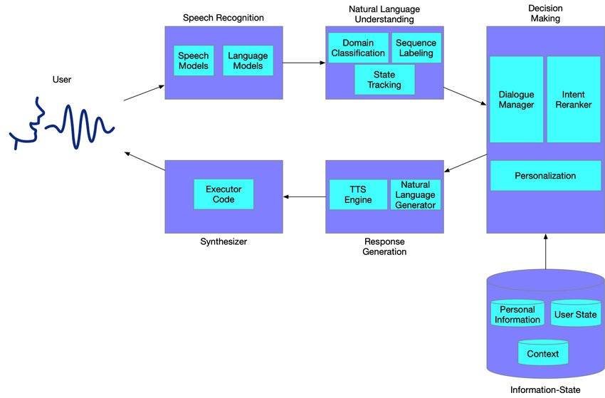

d

ACTIVITY CHART DIAGRAM
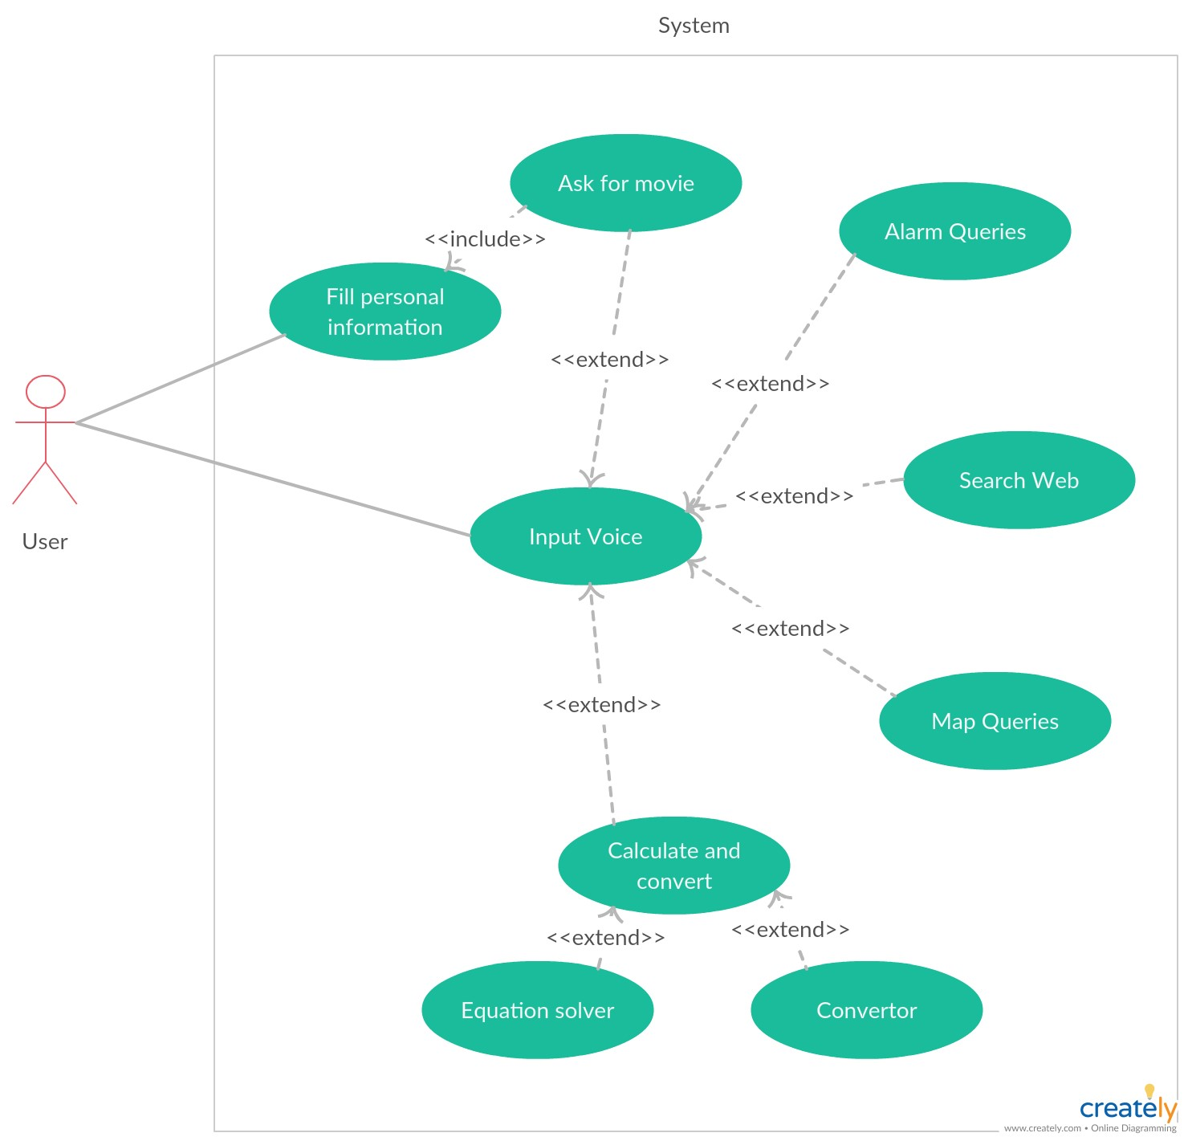

FLOW CHART

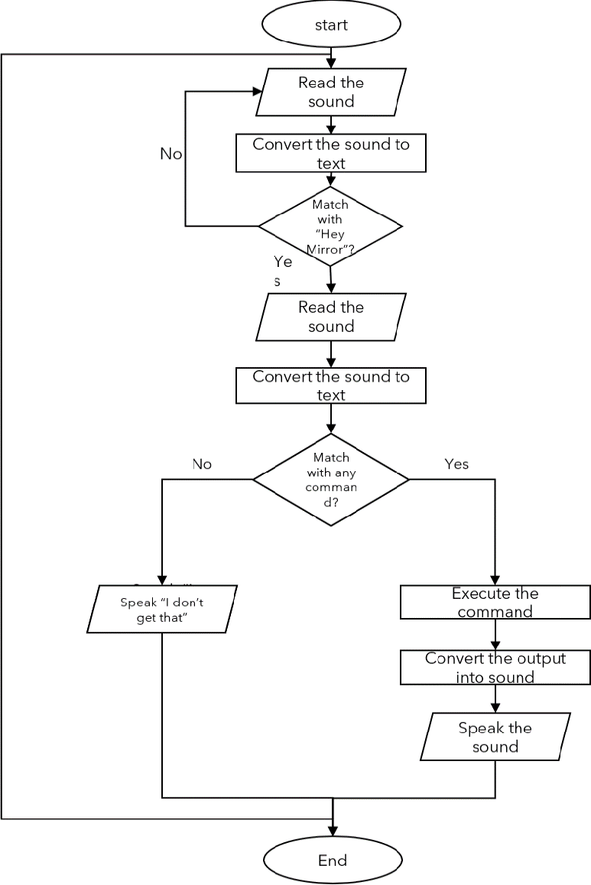

Modules
- Subprocess:- This module is used to get system subprocess details used in various commands i.e Shutdown, Sleep, etc. This module comes built-in with Python.
- Pyttsx3:- This module is used for the conversion of text to speech in a program it works offline. To install this module type the below command in the terminal.
- Wikipedia:- As we all know Wikipedia is a great source of knowledge just like GeeksforGeeks we have used the Wikipedia module to get information from Wikipedia or to perform a Wikipedia search. To install this module type the below command in the terminal.

- Speech Recognition:- Since we’re building an Application of voice assistant, one of the most important things in this is that your assistant recognizes your voice (means what you want to say/ ask). To install this module type the below command in the terminal.

- Web browser:- To perform Web Search. This module comes built-in with Python.
- Datetime:- Date and Time are used to showing Date and Time. This module comes built-in with Python.

SOURCE CODE

import pyttsx3
import datetime
import wikipedia
import pyaudio
import speech_recognition as sr
import webbrowser
import os
import random

engine = pyttsx3.init('sapi5')
voice = engine.getProperty('voices')
engine.setProperty('voice',voice[2].id)

def speak(audio):
engine.say(audio)
engine.runAndWait()

def wish_me():
hour = (datetime.datetime.now().hour)
if hour>=0 and hour<12:
speak("Good morning")
elif hour>=12 and hour<18:
speak("Good afternoon")
else:
speak("Good evening")
speak("Hello I am jarvius how may i help you")

def take_command():
r = sr.Recognizer()
with sr.Microphone() as source:
print("Listening.....")
r.pause_threshold = 1
audio = r.listen(source)

try:
print("Reconsing.....")
quary = r.recognize_google(audio,language='en-in')
print(f"User said {quary}")
except Exception as e:
print("Say this again")
return "None"
return quary

if __name__ == '__main__':
wish_me()
while True:
quary = take_command().lower()
if "wikipedia" in quary:
speak("searching wikipedia.....")
quary = quary.replace("wikipedia", "")
results = wikipedia.summary(quary, sentences=2)
speak("According to wikipedia")
print(results)
speak(results)

elif "open youtube" in quary:
webbrowser.open("youtube.com")

elif "open google" in quary:
webbrowser.open("google.com")

elif "open stack overflow" in quary:
webbrowser.open("stackoverflow.com")

elif "play movie" in quary:
randomNo = random.randint(0,16)
movies_dir = 'F:\\movies'
movies = os.listdir(movies_dir)
os.startfile(os.path.join(movies_dir, movies[randomNo]))

elif "open vs code" in quary:
path = "C:\\Users\\ASUS\\AppData\\Local\\Programs\\Microsoft VS Code\\Code.exe"
os.startfile(path)

elif "the time" in quary:
strTime = datetime.datetime.now().strftime("%H:%M:%S")
speak(f"The time is {strTime}")
print(f"The time is {strTime}")

elif "quit" and "exit" in quary:
exit()

FUTURE SCOPE
The next step will be to remove as much hardware as possible. With the ingenuity of the VA present in the clouds, being pulled in, and pushing its way into our lives with many devices in our bodies and our offices, homes, and cars. Your VA will always tell you about suggestions and take orders, and you will know more about yourself than you know yourself. We can expect this device to be installed and permanent.

bVoice Assistant is successfully made. Voice Assistant Controlled Personal Assistant System will use
the natural language processing (Python speech to text) and uses python speech interpreter
integrated with various code techniques to achieve a smart assistant that can control the computer
and applications and even solve user queries using web searches.
It can be designed to minimise the human efforts to interact with many other subsystems, which
would otherwise have to be performed manually. By achieving this, the system will make human
life comfortabl
BIBLOGRAPHY

Voice Assistant is successfully made. Voice Assistant Controlled Personal Assistant System will usethe natural language processing (Python speech to text) and uses python speech interpreterintegrated with various code techniques to achieve a smart assistant that can control the computerand applications and even solve user queries using web searches.It can be designed to minimise the human efforts to interact with many other subsystems, whichwould otherwise have to be performed manually. By achieving this, the vsystem will make humanlife comfortable.

References
1. Websites referred
•
• www.pythonprogra mming.net
• www.tutorialspoint. com
• www.google.co.in
2. YouTube channels referred
• CS dojo
• Edureka!
• codingwithharry

